Duty of Candour Report 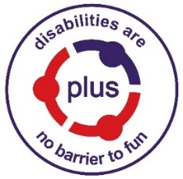
This report describes how our services have operated the duty of candour between 01.04.2025 – 31.03.26.

Duty of Candour
Duty of Candour is a legal requirement to ensure that if something goes wrong in health or social care services the people affected are offered an explanation, an apology and an assurance that staff will learn from the error. The learning is shared with the people affected and throughout Scotland.

Report
All health and social care services in Scotland must provide an annual Duty of Candour report for their service.
In the last year, there have been no incidents at PLUS to which the duty of candour applied.
Incidents triggered by the Duty of Candour were:
01/04/2025 - 31/03/2026 | 0

Our Policy & Procedure
All new staff learn about the Duty of Candour at their induction, and TURAS training for all Project Coordinators, Managers and Senior Management.
We have printed materials outlining the duty available to all staff and visitors at our sites.
When an incident occurs that triggers the Duty of Candour, our staff report this to the Safeguarding Lead Officer, who is responsible for ensuring that the Duty of Candour procedure is followed. The incident is recorded and reported to the Care Inspectorate and/or Health and Safety Executive, as appropriate.
When an incident of occurs, a working group comprised of relevant staff sets up a learning review, led by the Safeguarding Lead Officer. This allows everyone involved to review what happened and identify any changes or improvements for the future.
We know that serious mistakes can be distressing for staff as well as the families who use our services. If staff are affected by a Duty of Candour incident, they can access our Employee Assistance Programme for support.

If parents or children are affected by a Duty of Candour incident, we offer them support as necessary.
If you would like more information about this report, please contact our Head of Operations at karenmoffat@plusforthvalley.org.uk

